**Installation Guide**

Gigi Coffee

Version 1.0



Table of Contents

Summary 4

Desktop PC Point of Sale Setup 4

1 Restore Windows 4

2 Edit the POS Machine Power Option 10

3 Windows User Access Control (UAC) 10

4 Change Region 11

5 Enable System Restore & Change Computer Name 12

6 Apps Installation 14

6.1 7zip 15

6.2 Xilnex RetailPOS 15

6.3 TeamViewer 15

6.4 Driver Installation 16

6.4.1 Receipt Printer 16

6.4.1.1 Zywell Receipt Printer 17

6.4.1.2 Codesoft Receipt Printer 17

6.4.2 Label Printer 18

6.4.2.1 Gprinter Label Printer 18

6.4.2.2 Zywell Label Printer 19

6.4.3 Credit Card Terminal 19

6.4.3.1 Maybank Terminal 19

6.4.3.2 CIMB Terminal 19

Laptop Setup (HQ & Outlet) 20

1 Edit the Laptop Machine Power Option 21

2 Windows User Access Control (UAC) 21

3 Enable System Restore & Change Computer Name 22

4 Setup Admin Account & User Account 24

5 Apps Installation 27

5.1 7zip 28

5.2 Adobe Acrobat Reader 28

5.3 Microsoft 365 28

5.4 TeamViewer 29

5.5 Xilnex RetailPOS 30

5.6 SQL Financial Accounting 30

TV Menu Setup 31

1 Android TV 31

1.1 Android TV Setup 31

1.2 Android TV Configuration 34

1.3 TV Menu Apps Installation 37

2 Google TV 37

2.1 Google TV Setup 37

2.2 Google TV Configuration 37

2.3 TV Menu Apps Installation 37

# Summary

This is the installation guide made for IT users to set up new hardware by BTBrands and Gigi Coffee before deployed to the Outlet or HQ user.

# Desktop PC Point of Sale Setup

On this Chapter we will learn the how-to setup POS Machine before deploying it to Outlet. It will include settings changes that need to be done on the POS PC.

Desktop PC Point of Sale setup takes about 30mins.

Desktop PC Point of Sale full configuration takes about 5 hours to sync all xilnex database from cloud to Desktop PC.

# Restore Windows

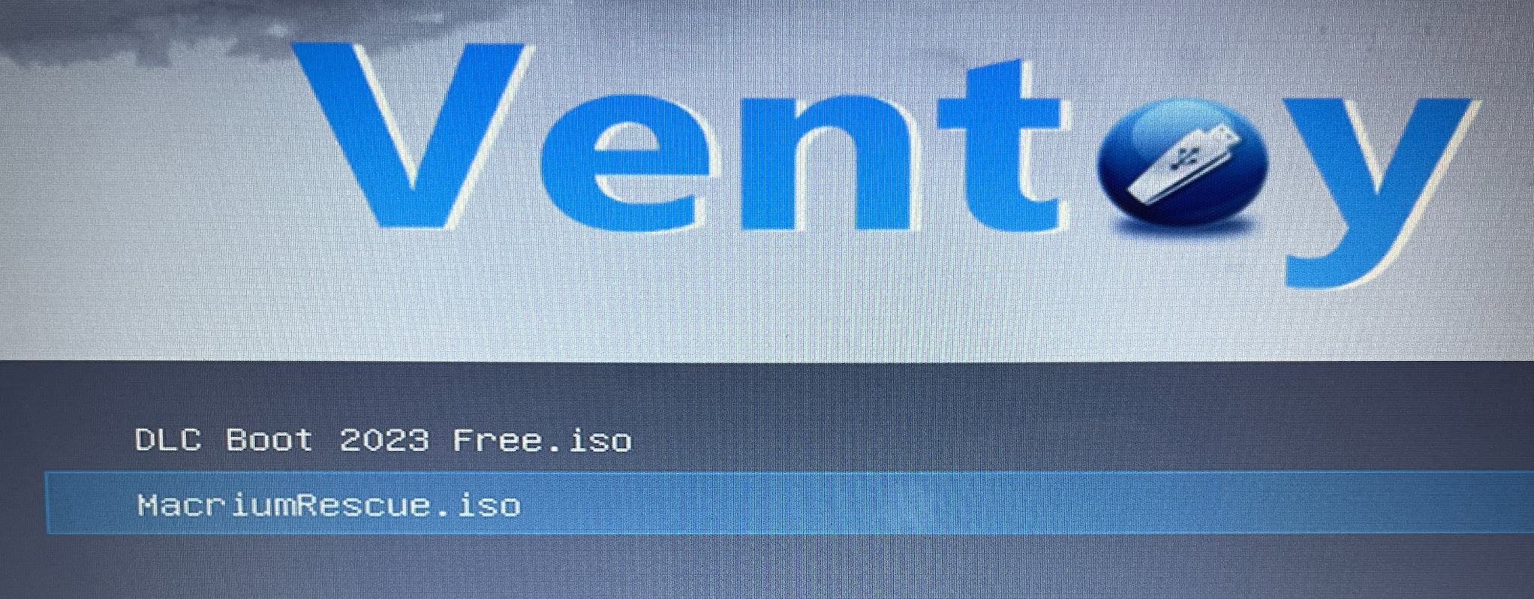

Figure 1

Boot into the Ventoy thumb drive provided, it needs to change boot order in bios first. Bios key for eTIMA POS machine is ‘Del’ key. If boot into the Ventoy is successful, select MacriumRescue.iso.

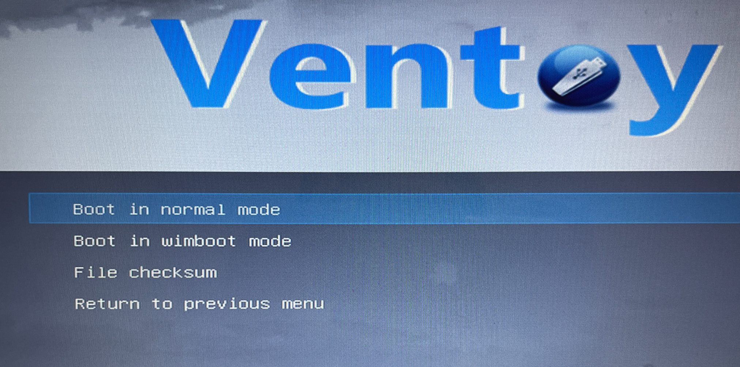

Figure 2

Then, select Boot in normal mode.

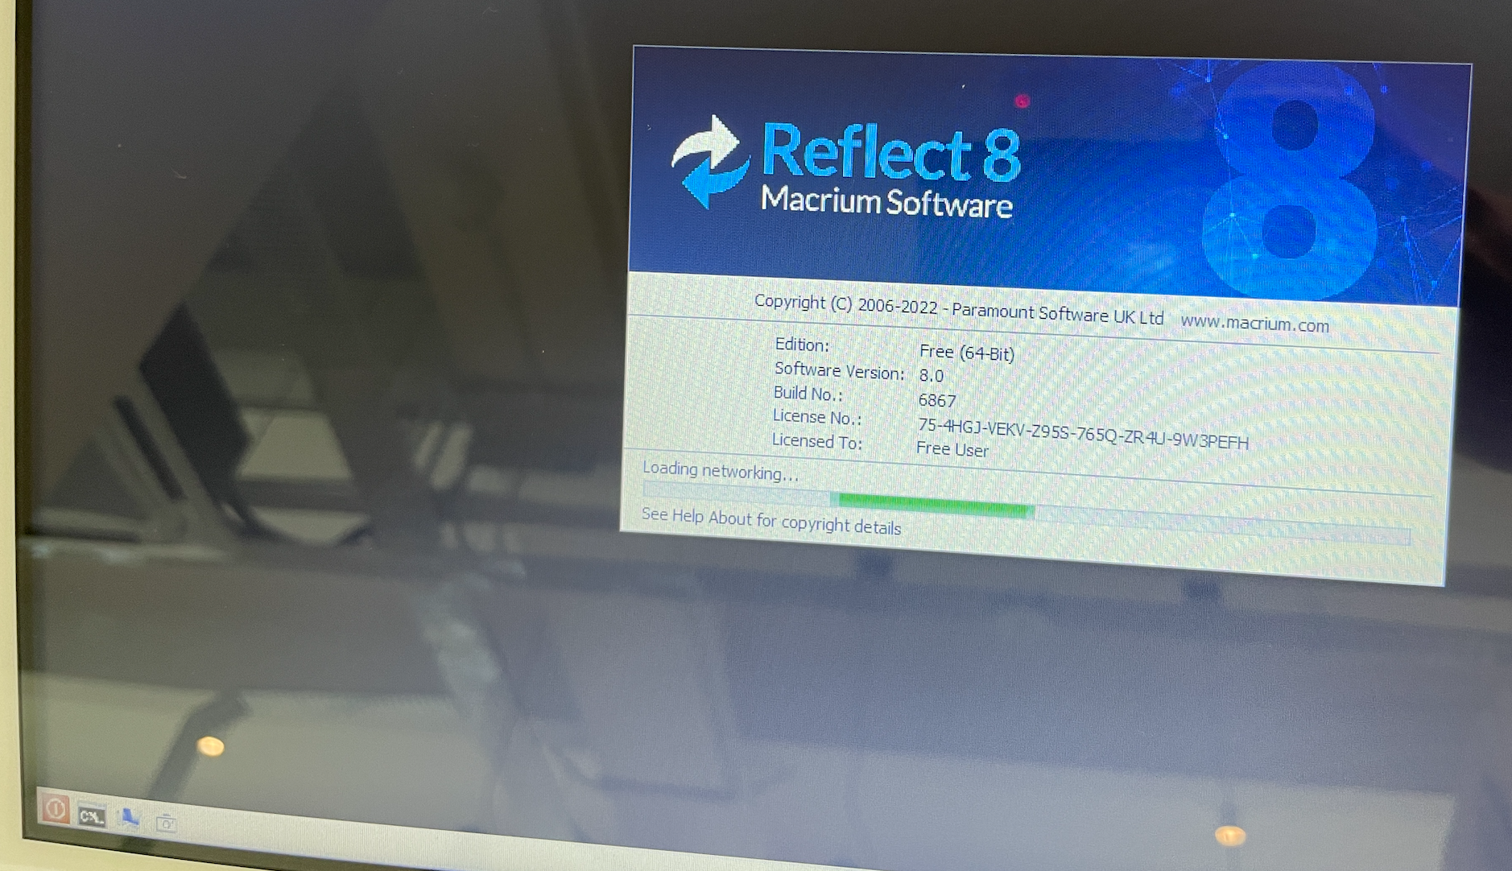

Figure 3

Wait for the Reflect 8 Macrium Software to finish loading.

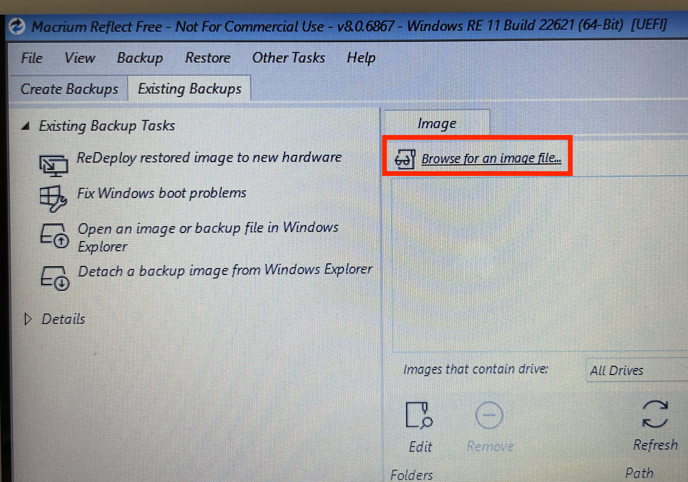

Figure 4

Then, this window will pop up. Now, select “Browse for an image file”.

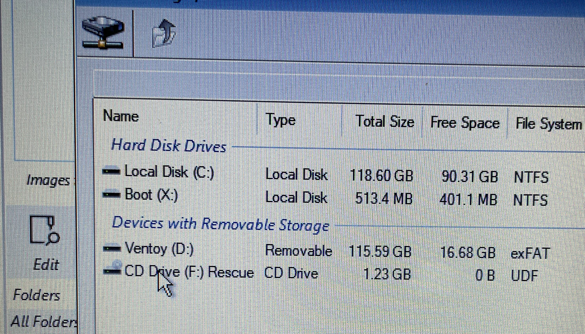 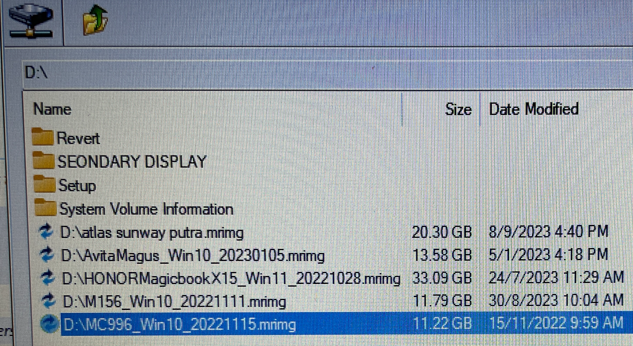

Figure 5.1 Figure 5.2

Then find the MC996 image file as shown in Figure 5.1. A new window will pop up and choose Ventoy (D:), then select “MC996_Win10_20221115.mrimg” as shown in Figure 5.2.

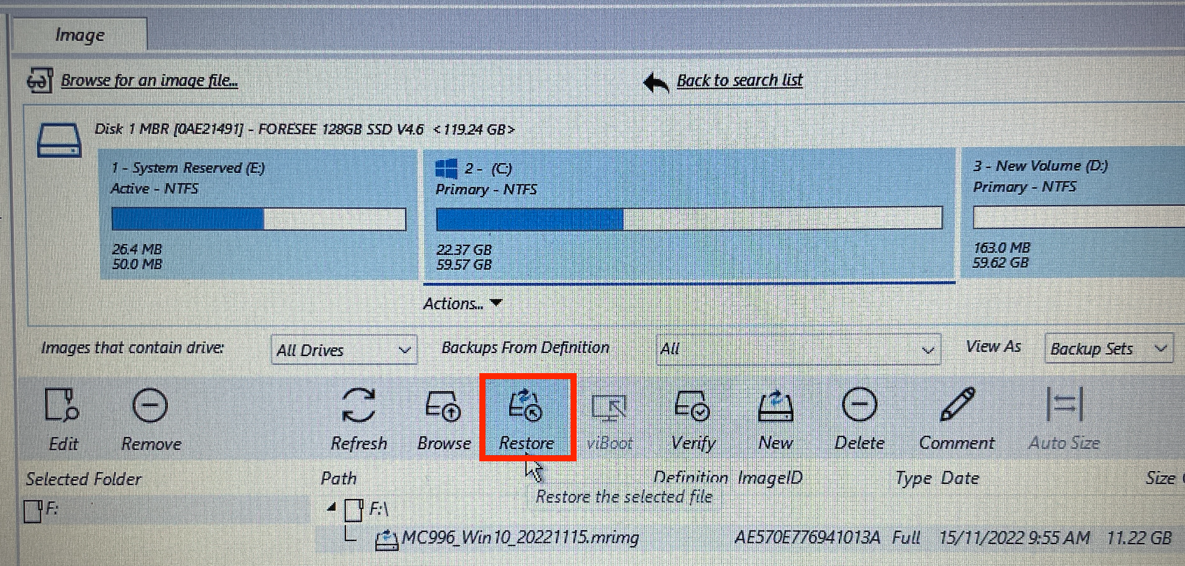

Figure 6

Then, click restore.

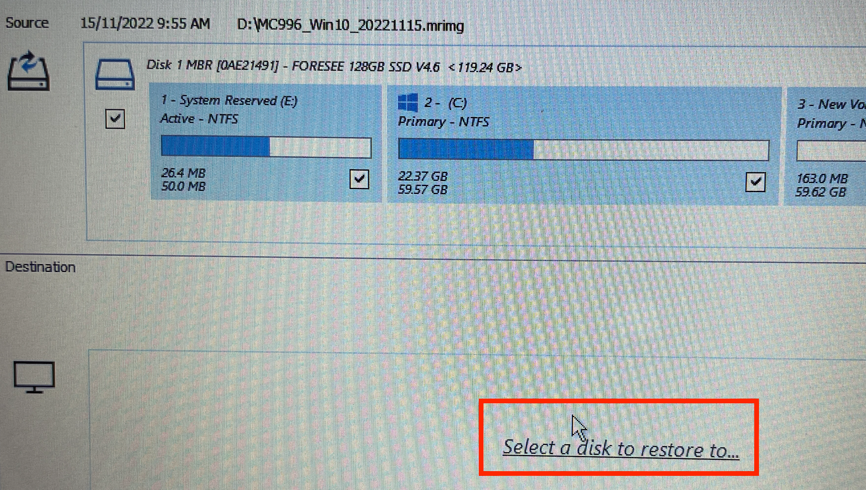

Figure 7

Click “Select a disk to restore to…”

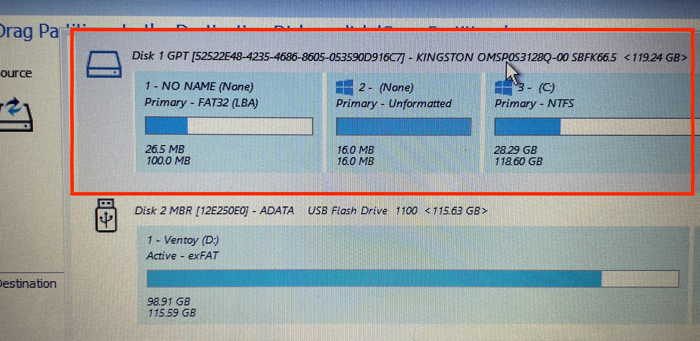

Figure 8

Here, make sure you CHOOSE DISK 1 as shown in Figure 8, it should have (C:) partition pre-installed. It is the main drive to boot into the POS system. If not, you will format the wrong drive and delete all the contents.

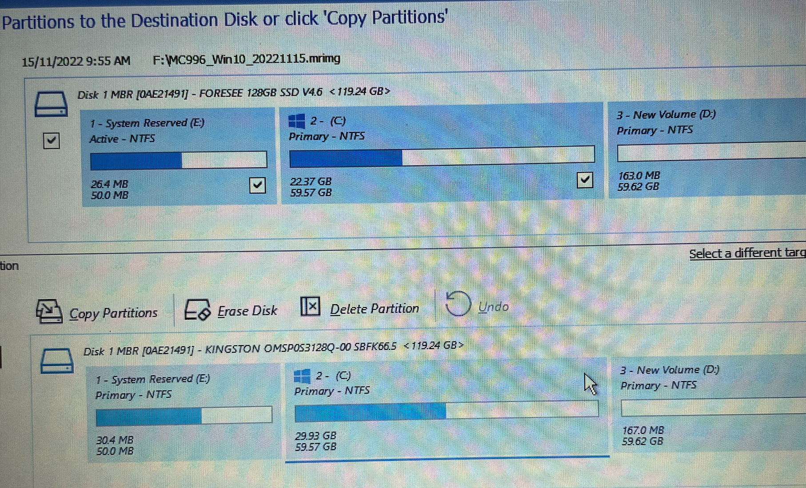

Figure 9

On the bottom row, click once on (C:) drive for safe measure as shown in Figure 9 and then click Continue.

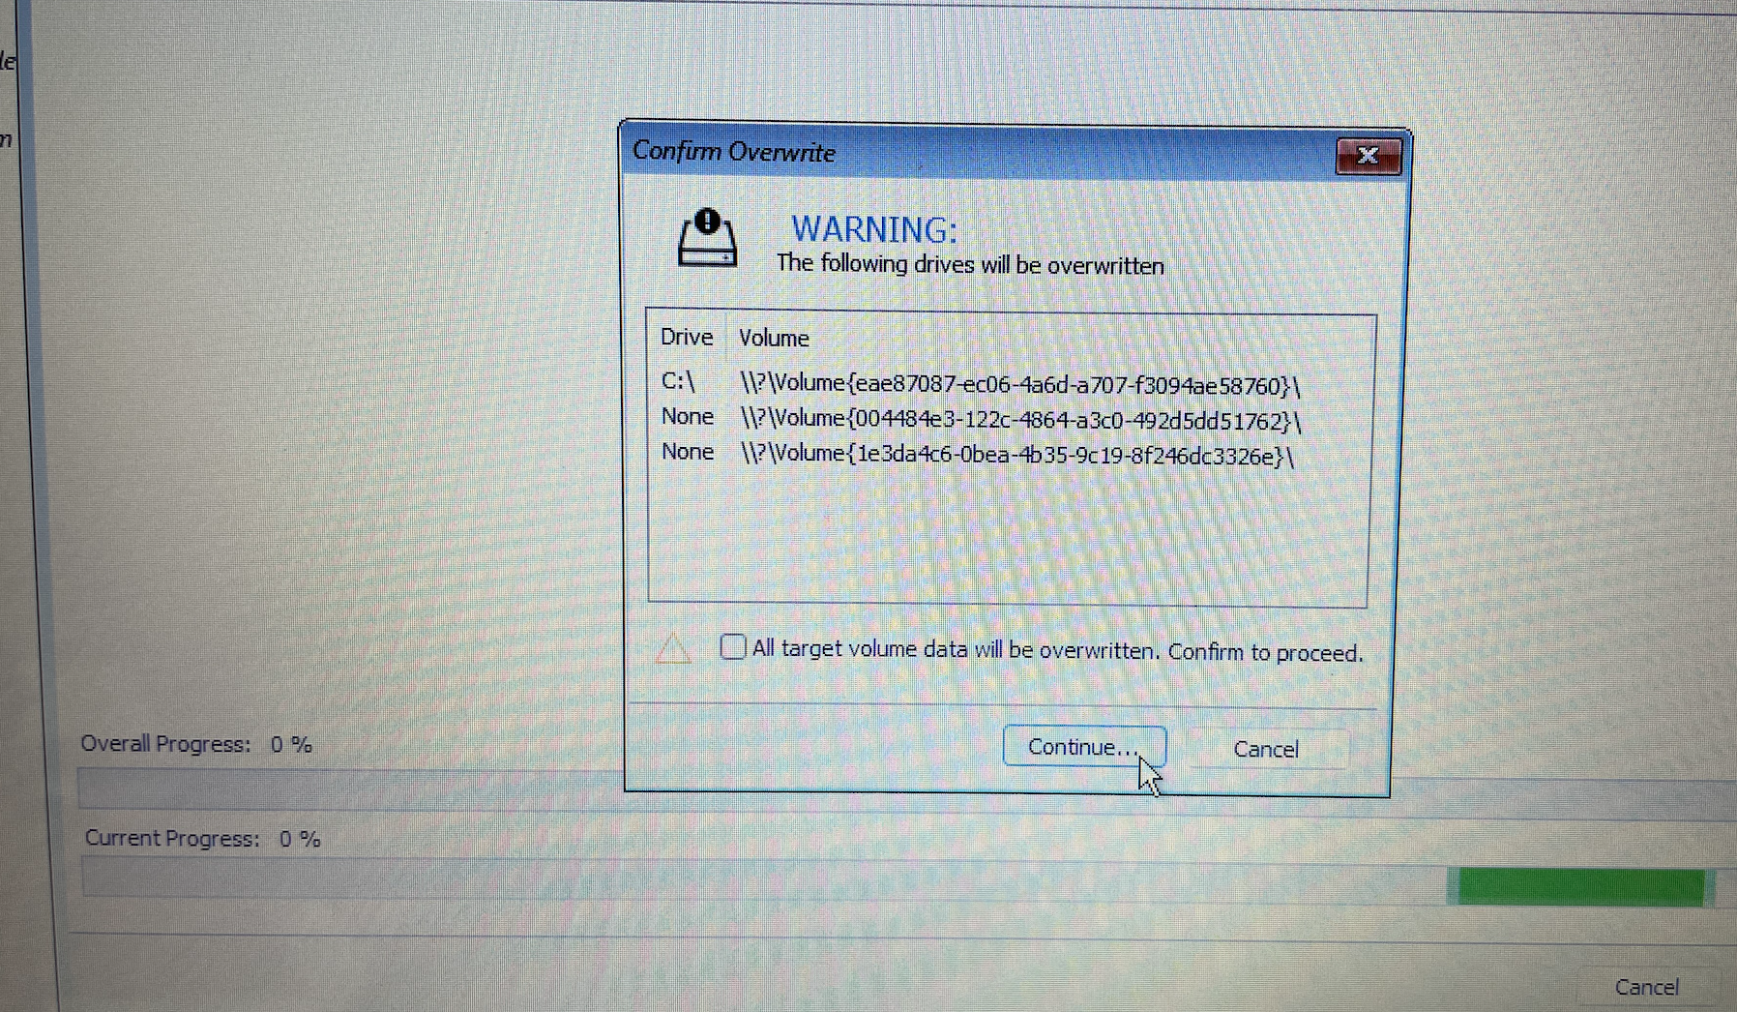 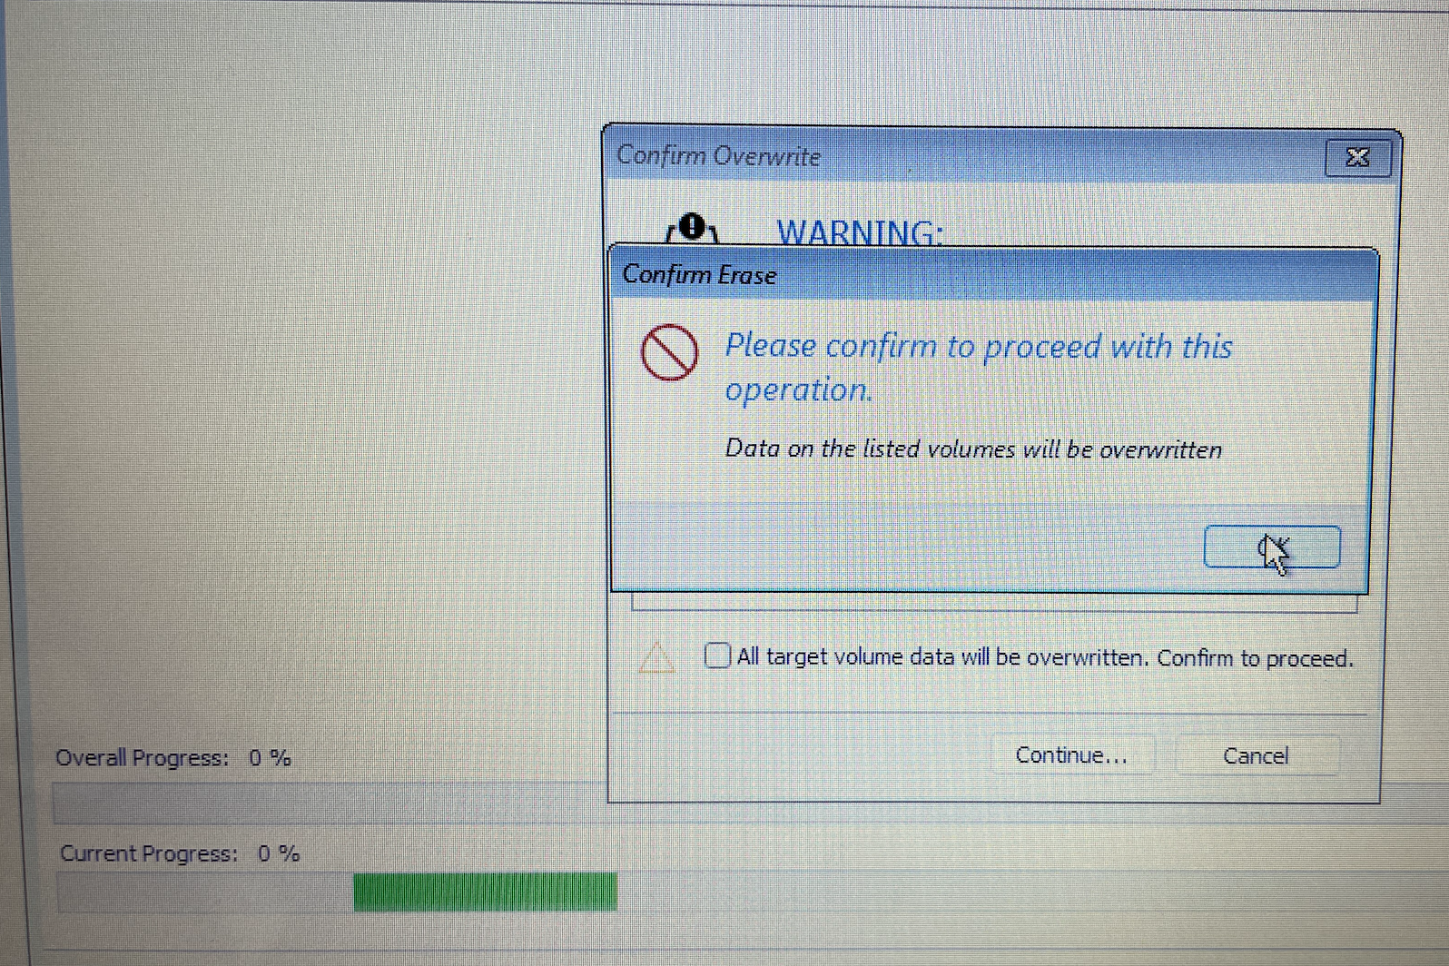

Figure 10.1 Figure 10.2

This warning pop up will shows up. Its to warn all the files inside the drive will be deleted. You can tick “All target“ to skip all the 3 warnings (they are all the same pop ups). Just click Continue and OK.

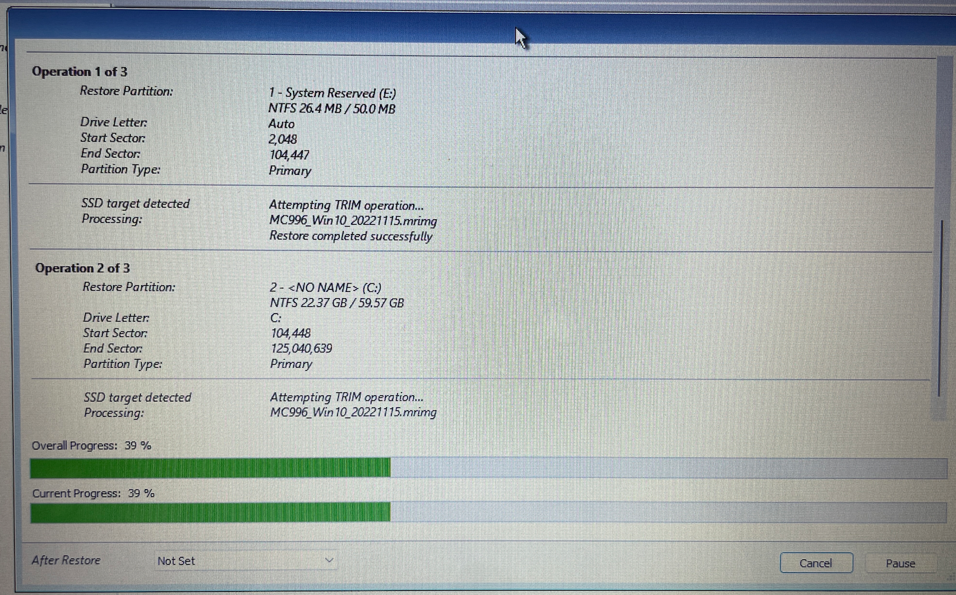 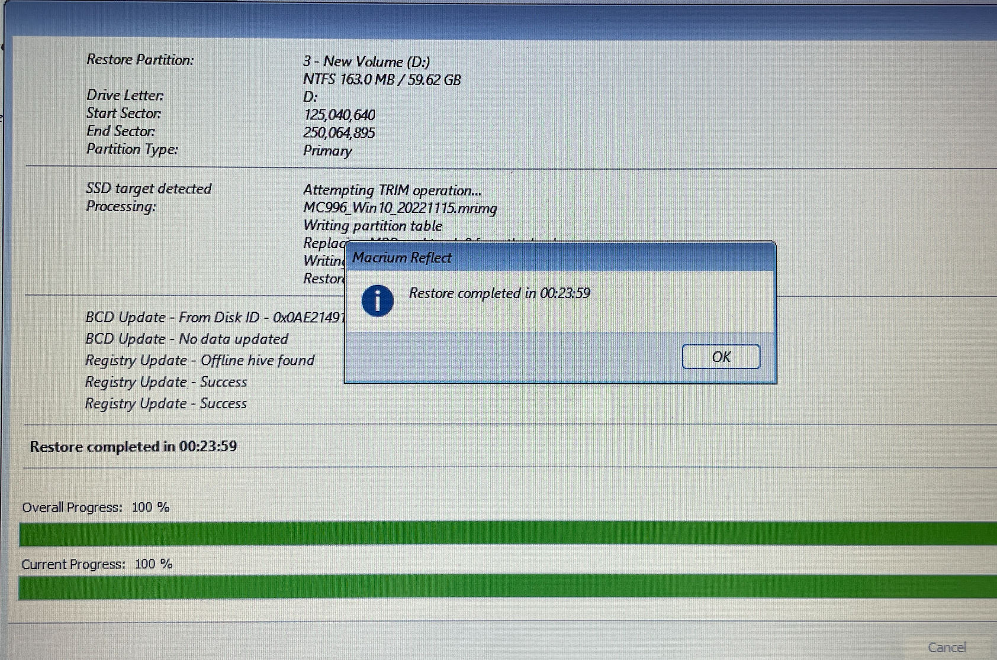

Figure 11.1 Figure 11.2

Now the software will start restore the system and complete pop up will show as in Figure 11.2.

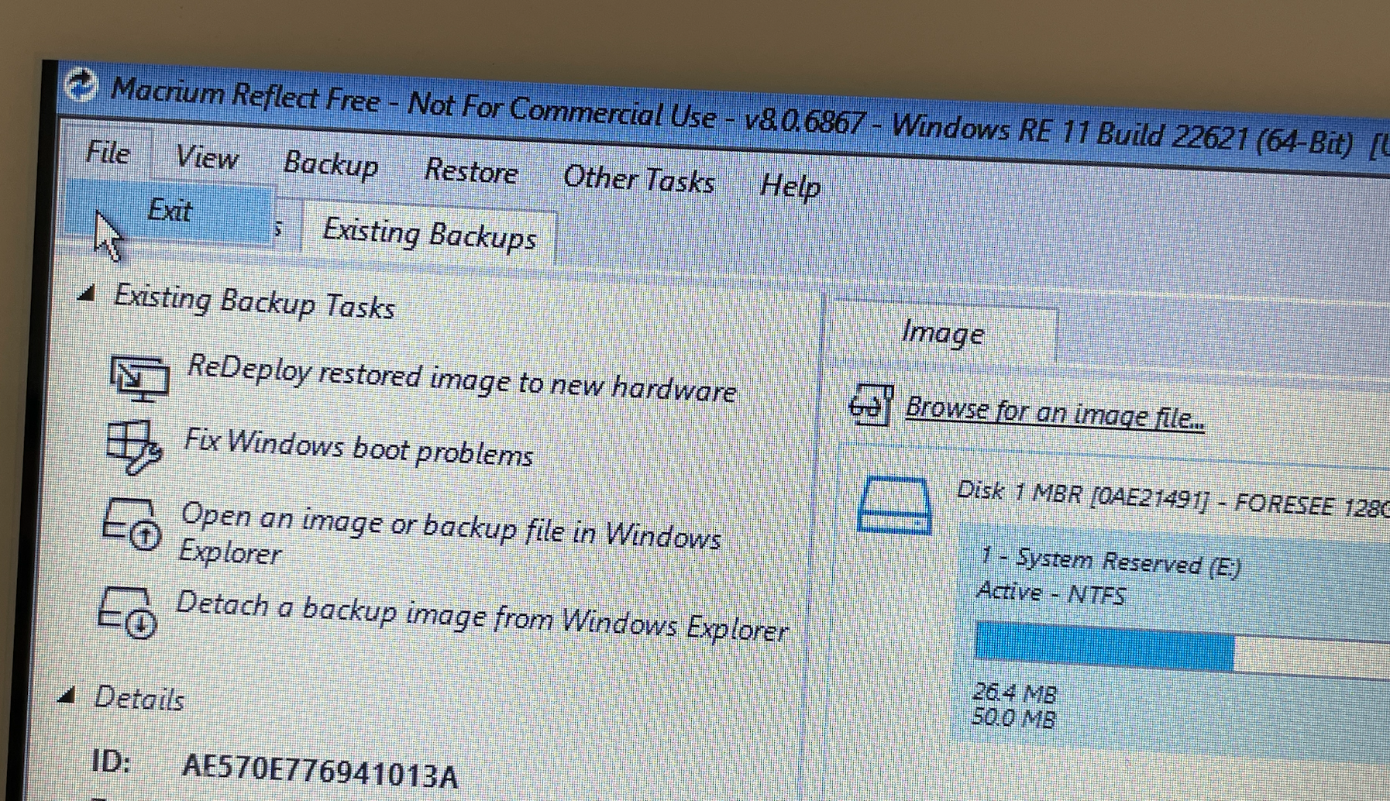

Then, click File and Exit on the very top left corner of the Macrium Reflect software. The system will reboot and pull off the Ventoy Thumb drive immediately. Then, the system should boot into Windows.

# Edit the POS Machine Power Option

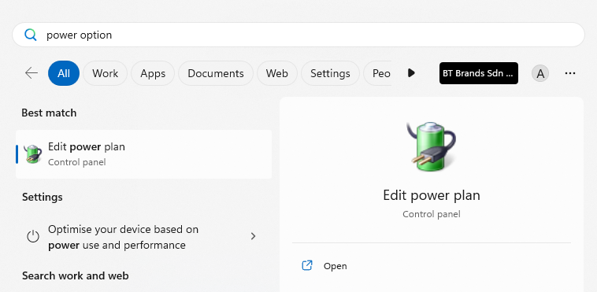

Go to Start, Search, and open **Edit power plan.**

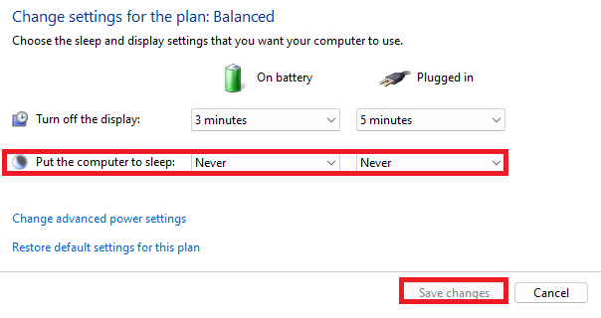

Change the **Put the computer to sleep** option to **Never** and save changes.

# Windows User Access Control (UAC)

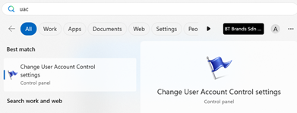

Go to Start, Search, and open **UAC (Change User Account Control settings)**

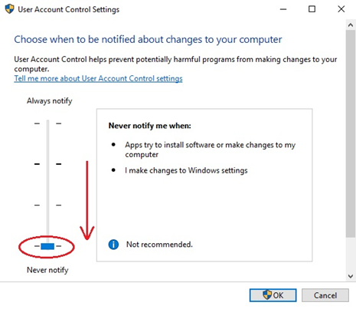

Low down to **Never notify** and click **OK.**

# Change Region

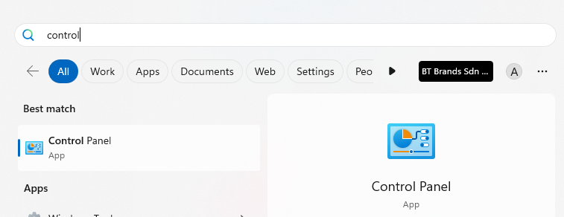

Go to Start, Search, and open **Control Panel.**

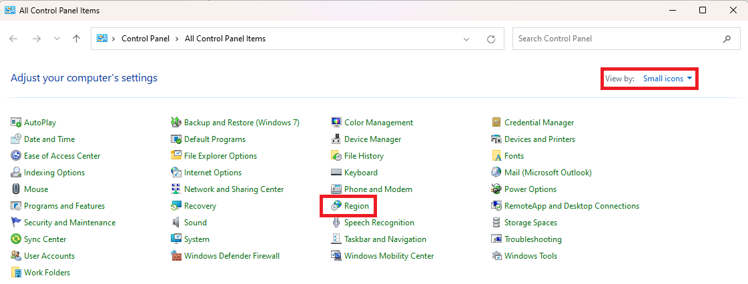

View by **Small icons** and click on **region**.

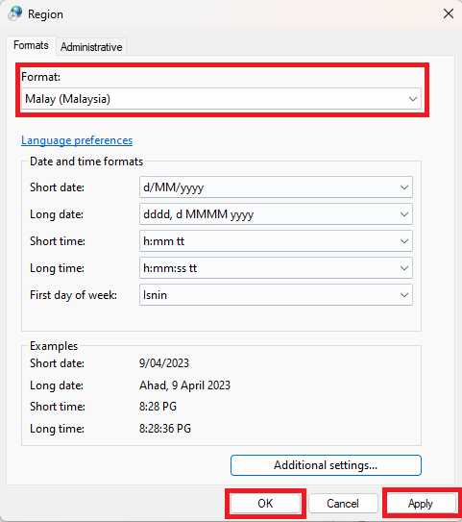

Change the format to **Malay (Malaysia)**, click on **Apply** and **OK** to save.

# Enable System Restore & Change Computer Name

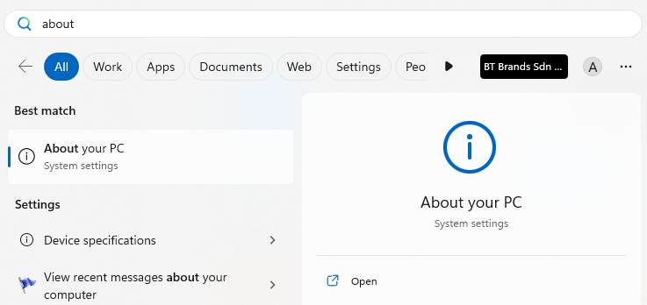

Go to Start, Search, and open **About your PC.**

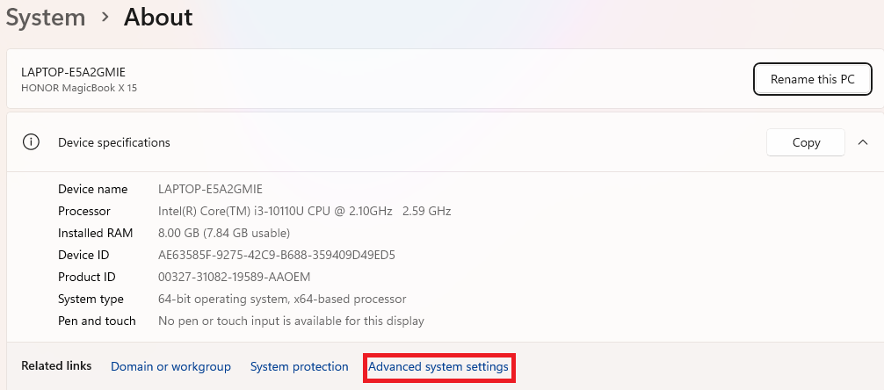

Open the **Advanced system settings.**

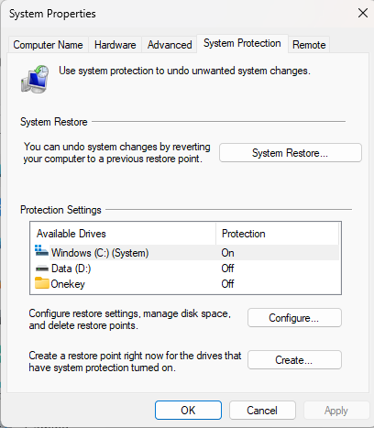 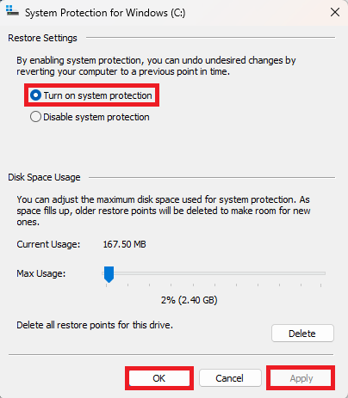

Go to **System Protection,** select **C Drive** and **Configure.** Enable system protection by **Turn on system protection,** click **Apply** and **OK.**

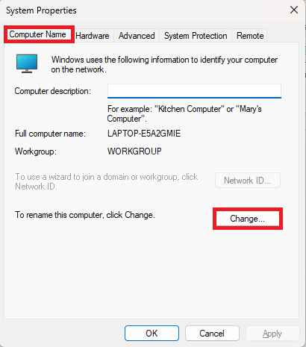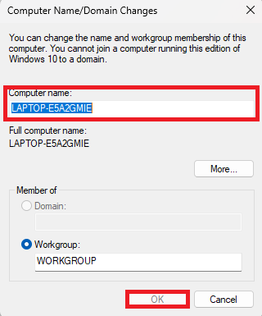

Go to **Computer Name** and click **Change** to rename the computer.

Rename the computer as per: **MY[Outlet Acronym]POS001.** Example: **MYPMJBPOS001** and click **OK.**

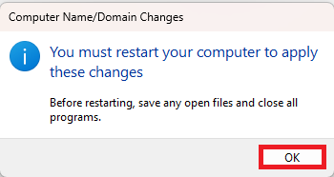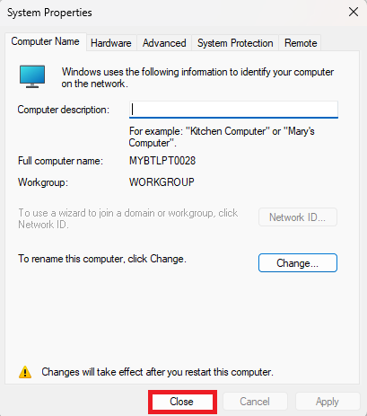

Click on **OK** and Click on **Close.**

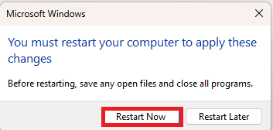

Click on **Restart Now** to apply changes.

# Apps Installation

Install all necessary apps needed for POS.

## 7zip

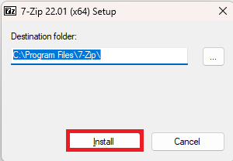 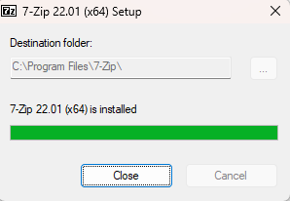

Open **7zip** installer and click on **Install.** Wait until installation is finished and click on **Close.**

## Xilnex RetailPOS

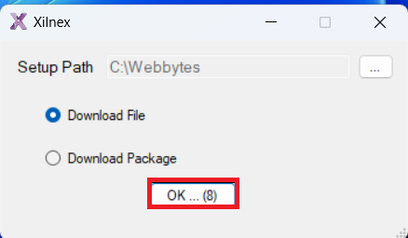 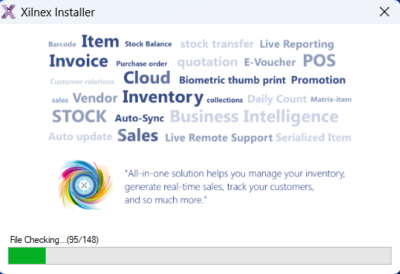

Click on Xilnex installer to start and click **OK.** Wait for the installer to run until it is complete.

## TeamViewer

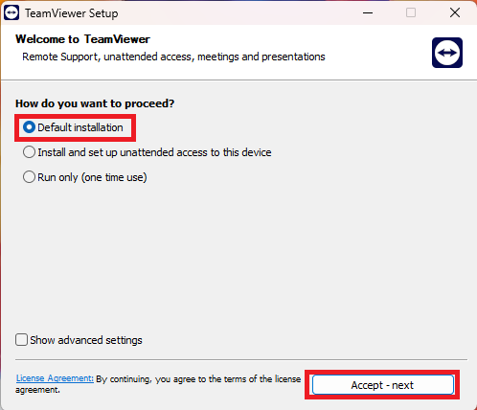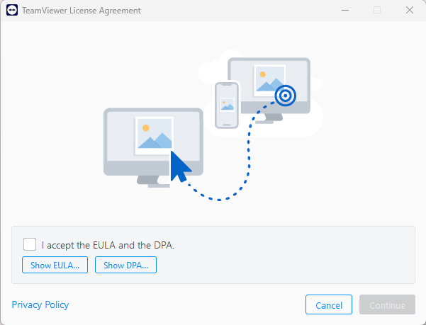

Run TeamViewer installer. Choose **Default** **installation** and click on **Accept** **–** **next**. Wait for the installation process to complete. Tick on **I accept the EULA and the DPA** and click on **Continue**.

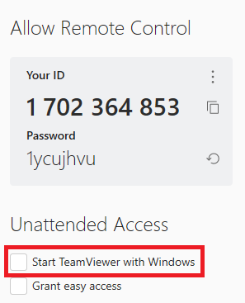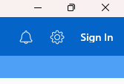

Tick on **Start TeamViewer with Windows** and then click on **Settings**.

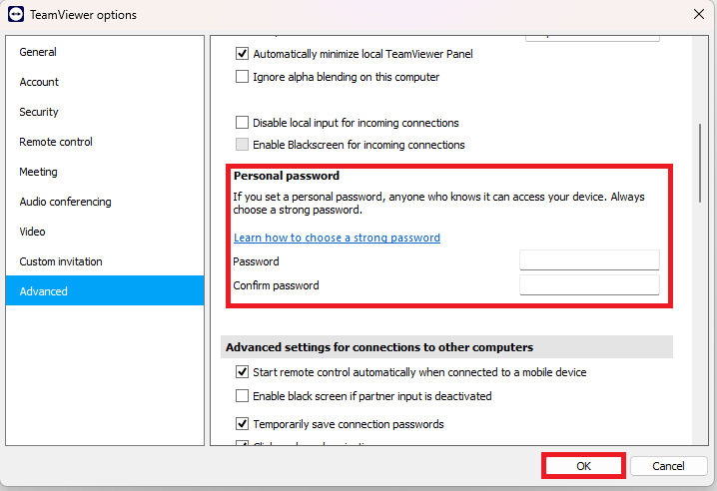

After that, choose **Advanced**. Scroll down to **Personal** **password** and set password: **cBm1@45964** and then click on **OK**.

## Driver Installation

The printers need to set the IP Address first to become network printers, then we can proceed to install the drivers. Install Driver needed for POS. (Receipt Printer, Label Printer and Credit Card Terminal).

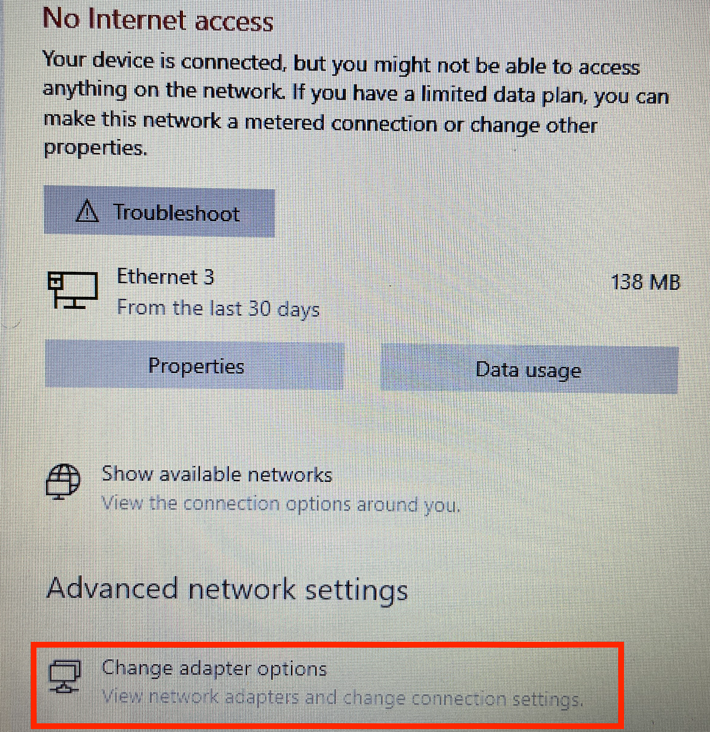

First, connect the printer to the POS system via Ethernet cable (LAN cable).

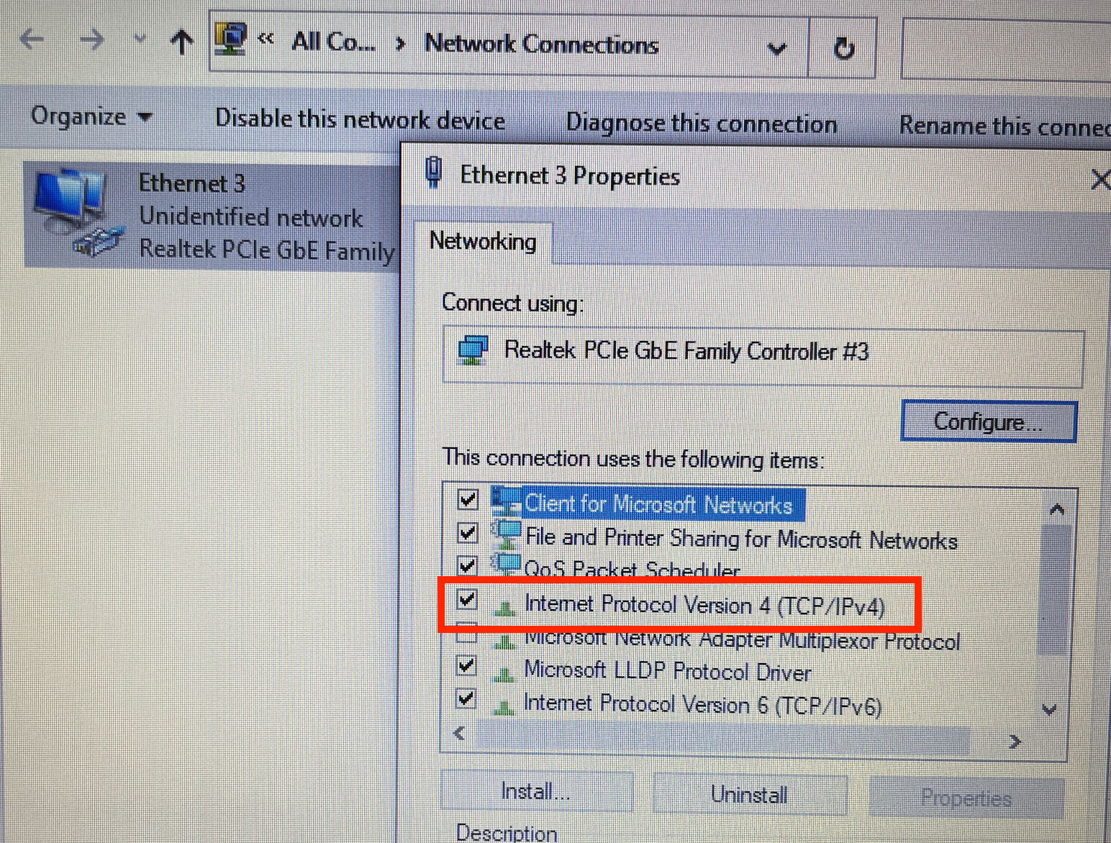

Double click on Ethernet (the number could be random, it does not effect anything). Then Ethernet Properties window will appear, then double click on the TCP/IPv4.

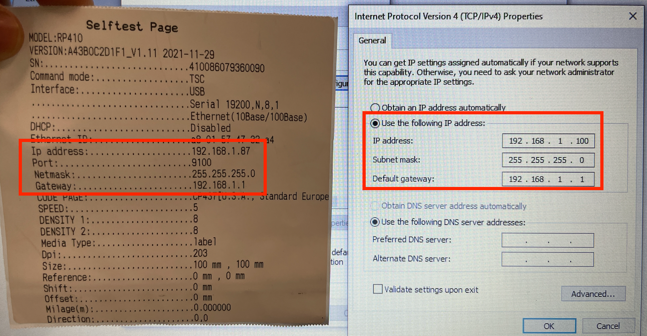

The example above is setup the IP Address for Rongta Printer.

Set the forth octet of the IP Address ( 192.168.1.XXX ) to any number except 87 (the IP address should not be the same, 192.168.1.87). For example here, 192.168.1.100

Subnet and default gateway follows as the selftest page. Then click OK.

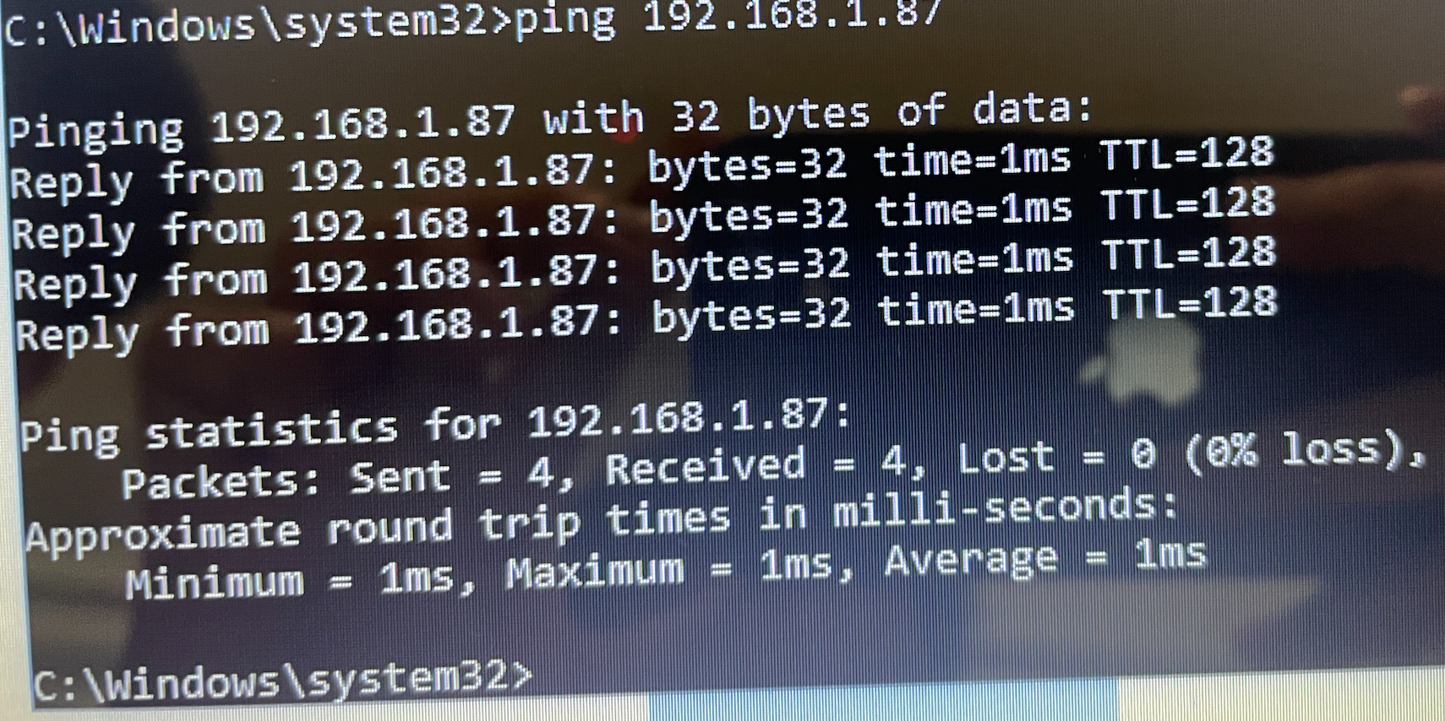

Ping to printer’s default IP to check connection.

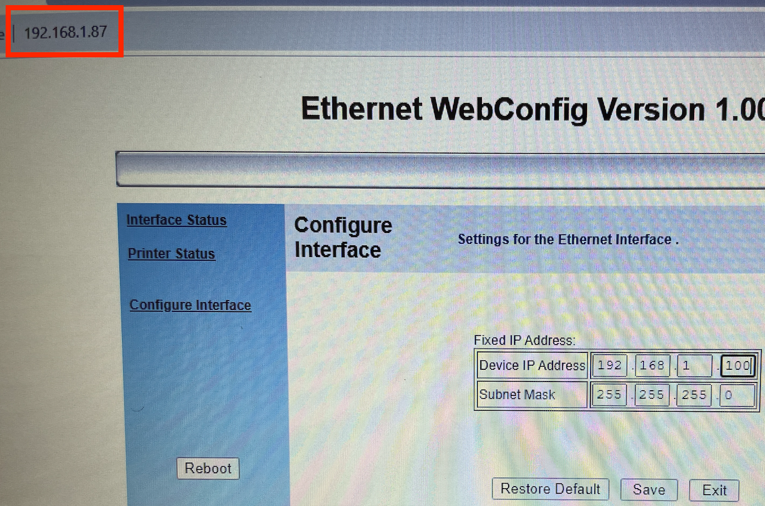

Then, change the printer’s IP address to the same network. In this case, the third octet of the network is 169 (192.168.169.1).

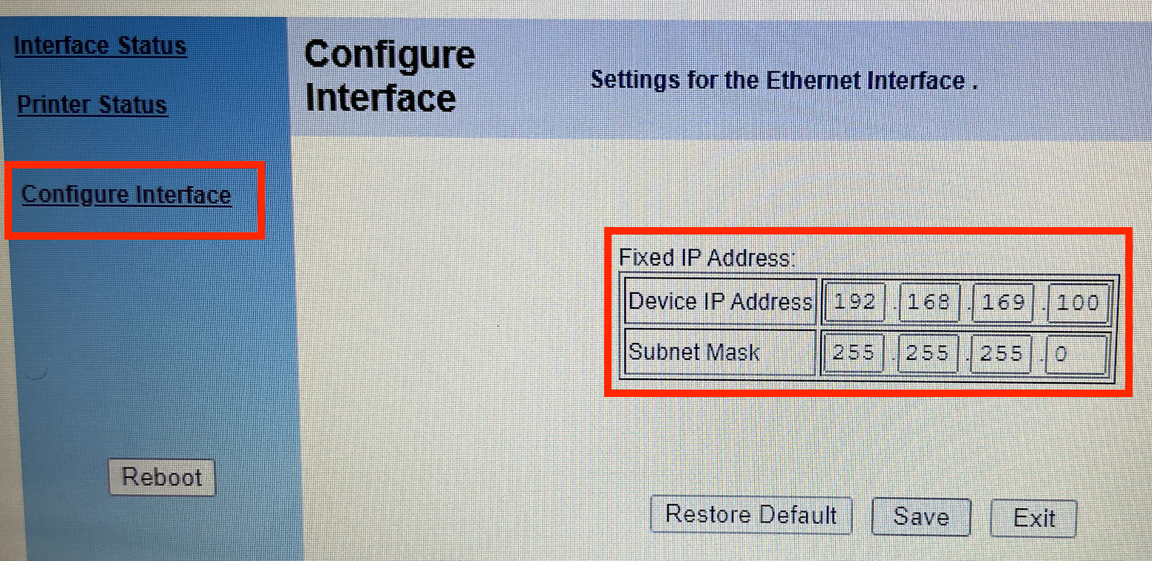

Navigate to Configure Interface and set the IP address to the same network. The example as shown above 192.168.169.100. The third octet must follow the network’s IP address, the forth octet is defined by the user.

Then, continue with installing the driver via USB.

### Receipt Printer

Setup receipt printer driver. There are 2 types of receipt printer driver based on the model used.

#### Zywell Receipt Printer

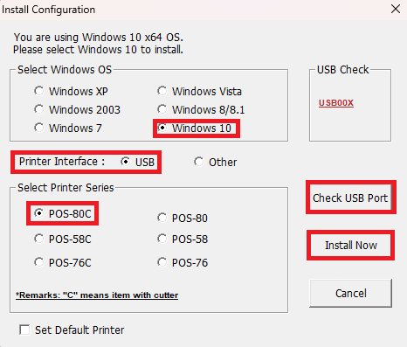

Run the Zywell receipt printer installer to start installation. Click on the **Check USB Port** to check the port used for receipt printer. Choose **Windows OS – Windows 10, Printer Interface - USB** and **Printer** **Series – POS-80C** and then click on **Install** **Now**. Wait until the driver installation to be completed.

#### Codesoft Receipt Printer

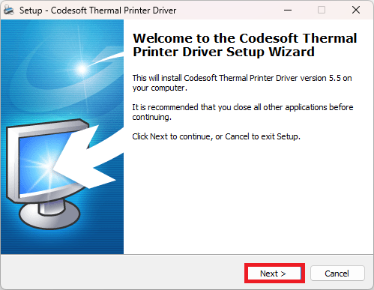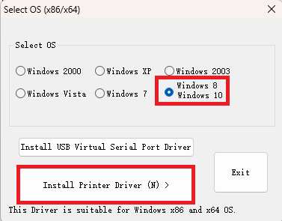

Run the Codesoft receipt printer installer to start the installation. Click on **Next**, select **OS – Windows 10** and click on **Install Printer Driver (N)**.

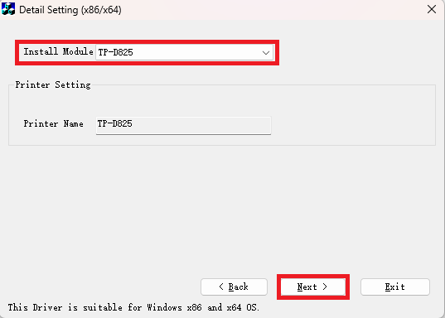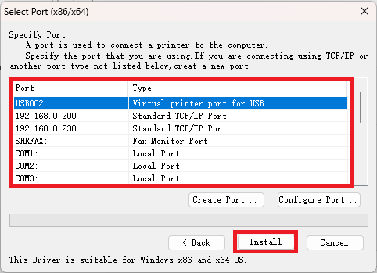

Select **Install Module – TP-D825**, choose the correct **Port type** used and click on **Install**.

### Label Printer

Setup label printer for POS use. There are 2 types of label printer driver based on the model used.

#### Gprinter Label Printer

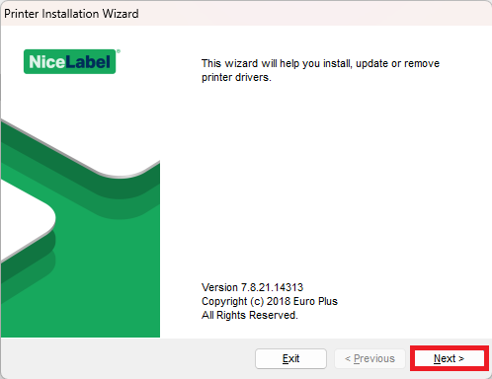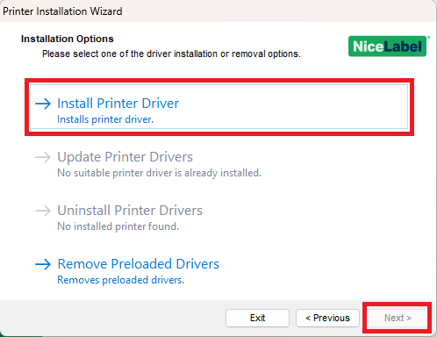

Run the Gprinter Label printer installer, click **Next**. Select **Install Printer Driver** and click **Next**.

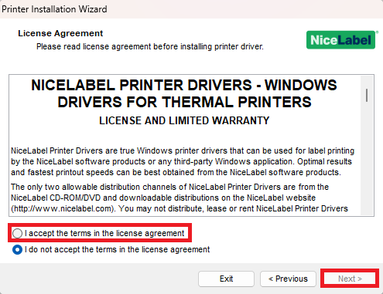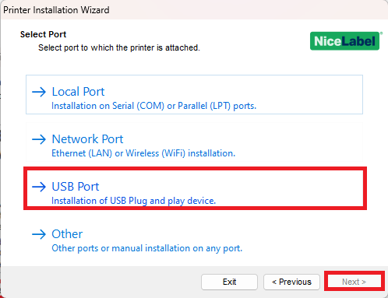

Select **I accept the terms in the license agreement** and click **Next**. Select **Port** **–** **USB Port** and click **Next**.

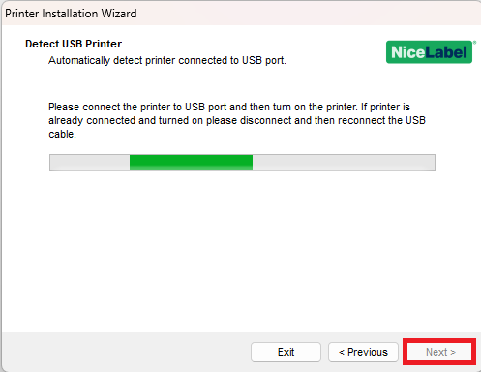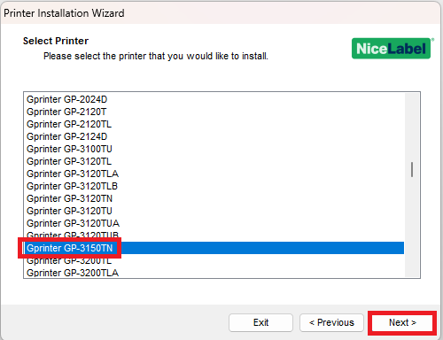

Follow the instructions to detect the USB Printer and click **Next**. Scroll down, select the **printer** **– Gprinter GP-3150TN** and click **Next**.

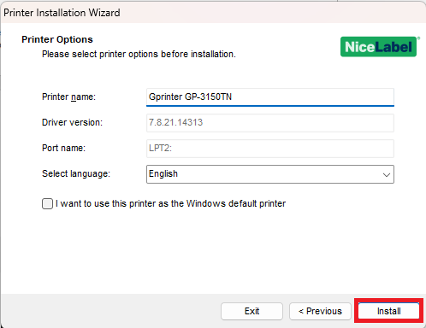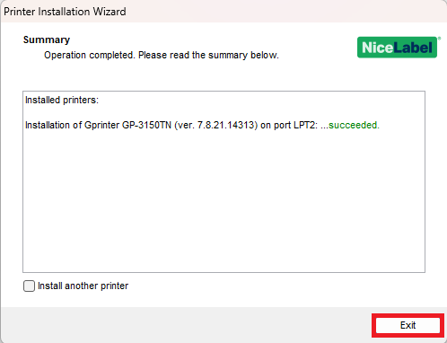

Check the Printer Options and click **Install**. Wait for the driver installation complete and click **Exit**.

#### Zywell Label Printer

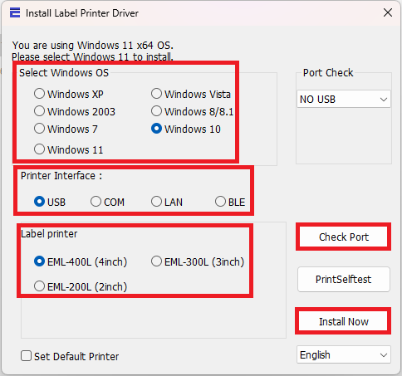

Run the Zywell Label Printer Installer. Click on **Check** **Port** to detect which port to install driver. Choose **Windows OS – Windows 10**, **Printer Interface – USB**, **Label Printer – EML-400L (4inch)** and click on **Install Now**.

#### Rongta Label Printer

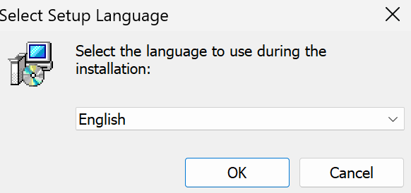 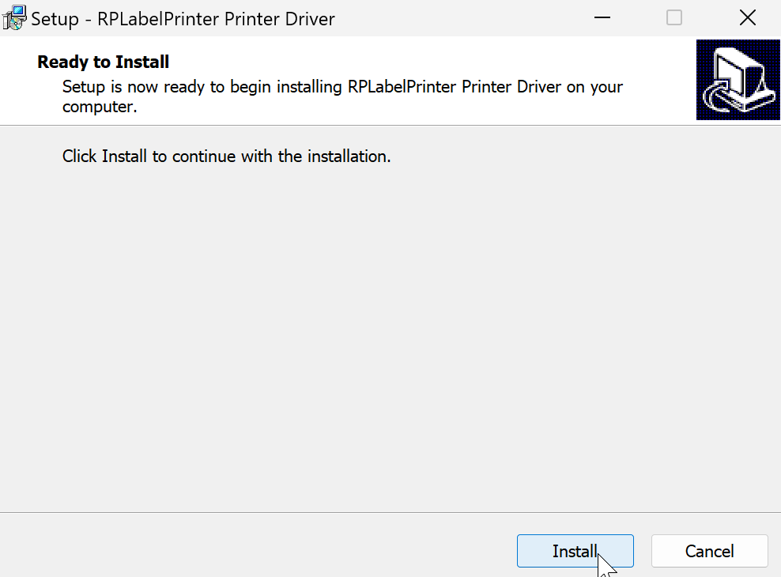

Run the Rongta Label Printer Installer. Just select English and click **Install**.

### Credit Card Terminal

#### Maybank Terminal

Plug in the Maybank Credit Card Terminal by using the USB Serial cable to the POS. Run the Maybank Credit Card Terminal installer to install the driver.

#### CIMB Terminal

Plug in the CIMB Credit Card Terminal by using the USB Serial cable to the POS.

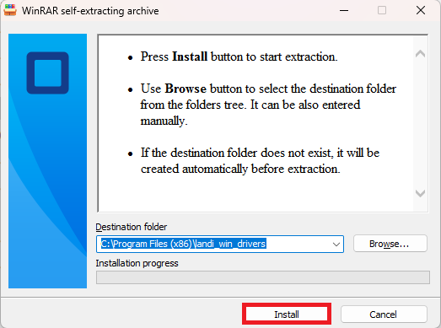

Run the CIMB Credit Card Terminal installer to install the driver. Click **Install**.

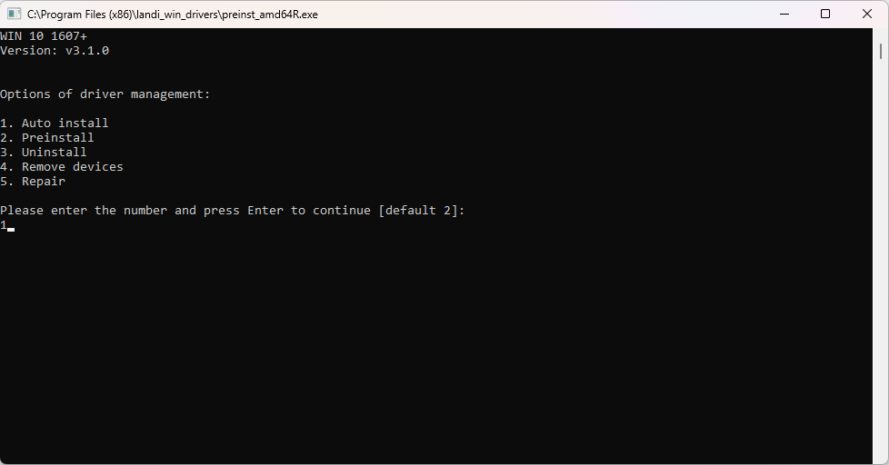

Key-in the Options of driver management, select **1** for Auto install.

Wait for the driver installation to be completed and close.

# Laptop Setup (HQ & Outlet)

On this Chapter we will learn the how-to setup POS Machine before deploying it to Outlet. It will include settings changes that need to be done on the POS PC.

Desktop PC Point of Sale setup takes about 30mins.

Desktop PC Point of Sale full configuration takes about 5 hours to sync all xilnex database from cloud to Desktop PC.

# Edit the Laptop Machine Power Option



Go to Start, Search, and open **Edit power plan.**



Change the **Put the computer to sleep** option to **Never** and save changes.

# Windows User Access Control (UAC)



Go to Start, Search, and open **UAC (Change User Account Control settings)**



Low down to **Never notify** and click **OK.**

# Enable System Restore & Change Computer Name



Go to Start, Search, and open **About your PC.**



Open the **Advanced system settings.**

 

Go to **System Protection,** select **C Drive** and **Configure.** Enable system protection by **Turn on system protection,** click **Apply** and **OK.**



Go to **Computer Name** and click **Change** to rename the computer.

Rename the computer as per table below and click **OK.**

|  |  |  |
| --- | --- | --- |
|  | **Format** | **Example** |
| **BTBrands HQ Laptop** | MYBTLPT[**Number**] | MYBTLPT0028 |
| **Gigi Coffee Outlet Laptop** | MY[Store Acronym]LPT001 | MYPMJBLPT001 |



Click on **OK** and Click on **Close.**



Click on **Restart Now** to apply changes.

# Setup Admin Account & User Account

Setup user account as per below:

|  |  |  |  |
| --- | --- | --- | --- |
| **Accounts** | **Username** | **Password** | **Security Question Answer** |
| Administrator | Administrator1 | P@ssword123 | 1. bt 2. bt 3. bt |
| User | [Laptop Username]  Ex. **Azril** | Do not set |  |

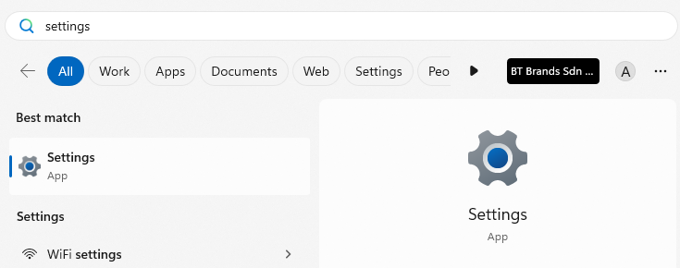

Go to Start, Search and open **Settings**.

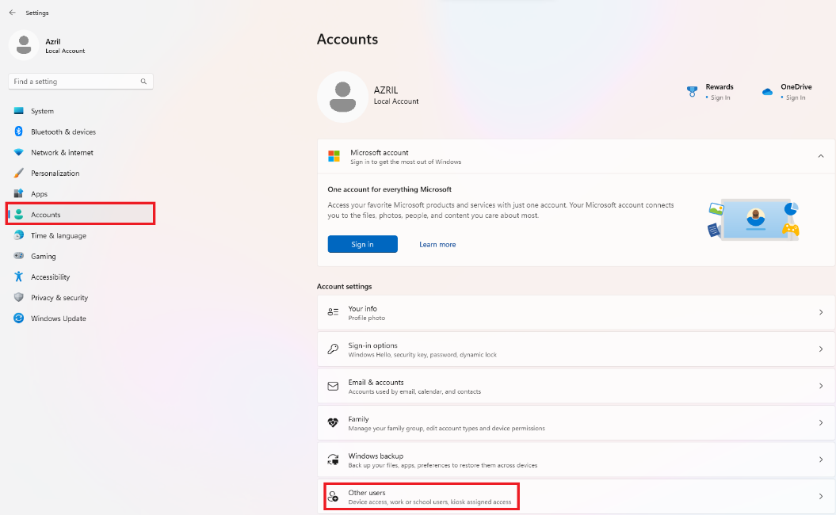

Select **Account** and click on **Other users**.

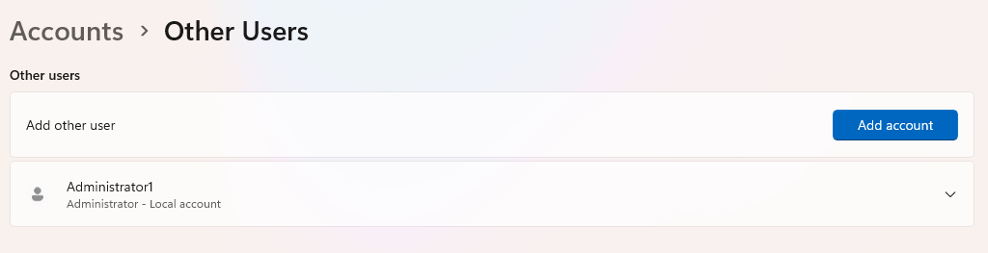

Click on **Add** **account** to add new user account.

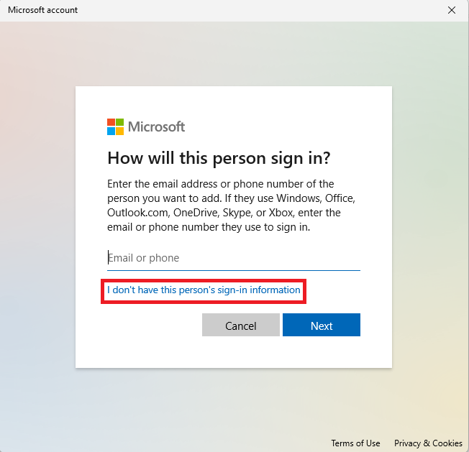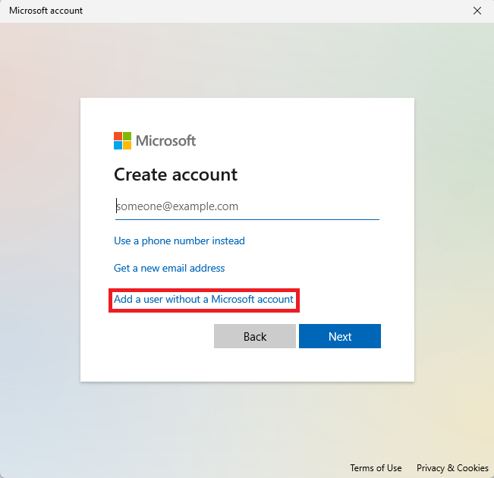

Click on **I don’t have this person’s sign-in information** and **Add a user without Microsoft account**.

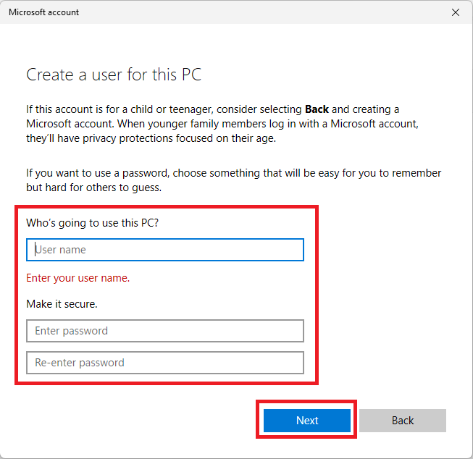

Key in the **Username** and **Password** for the account creation as provided in the table earlier and click **Next**.

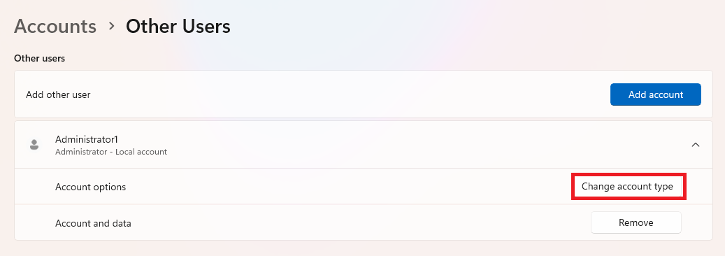

After account creation, click on the user, click on **Change account type**.

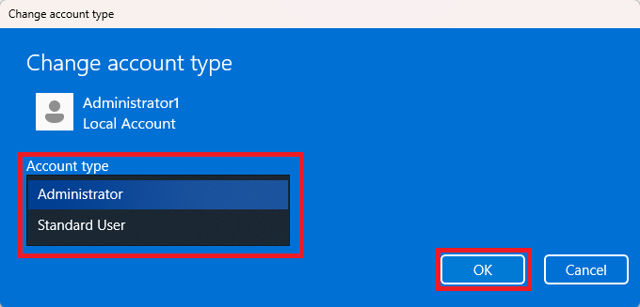

Change the **Account** **type** to **Administrator** and click on **OK**.

# Apps Installation

Apps needed to be installed for laptop as per below table:

|  |  |  |
| --- | --- | --- |
| **Apps** | **Gigi Coffee Laptop** | **BTBrands HQ Laptop** |
| **7zip** | To be Install | To be Install |
| **Adobe Acrobat Reader** | To be Install | To be Install |
| **Microsoft 365** | To be Install | To be Install |
| **AnyDesk** | To be Install | To be Install |
| **TeamViewer** | To be Install | To be Install |
| **Xilnex RetailPOS** | Optional (When Request) | Optional (When Request) |
| **SQL Financial Accounting** | Optional (When Request) | Optional (When Request) |

## 7zip

 

Open **7zip** installer and click on **Install.** Wait until installation is finished and click on **Close.**

## Adobe Acrobat Reader

## Microsoft 365

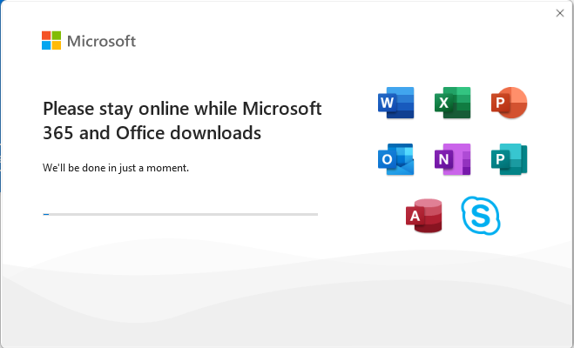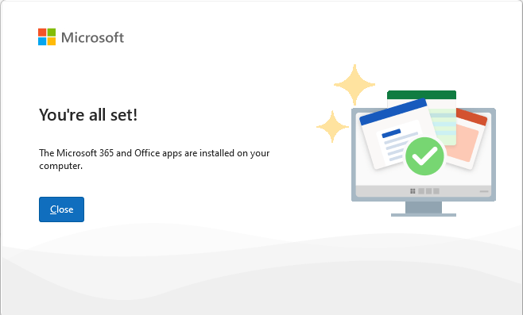

Run the Microsoft 365 Installer, wait until installation is complete and click **Close**.

## TeamViewer



Run TeamViewer installer. Choose **Default** **installation** and click on **Accept** **–** **next**. Wait for the installation process to complete. Tick on **I accept the EULA and the DPA** and click on **Continue**.



Tick on **Start TeamViewer with Windows** and then click on **Settings**.



After that, choose **Advanced**. Scroll down to **Personal** **password** and set password: **cBm1@45964** and then click on **OK**.

## Xilnex RetailPOS

 

Click on Xilnex installer to start and click **OK.** Wait for the installer to run until it is complete.

## SQL Financial Accounting

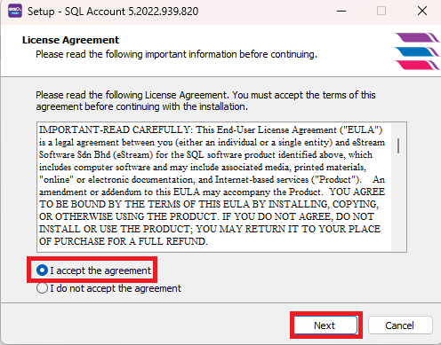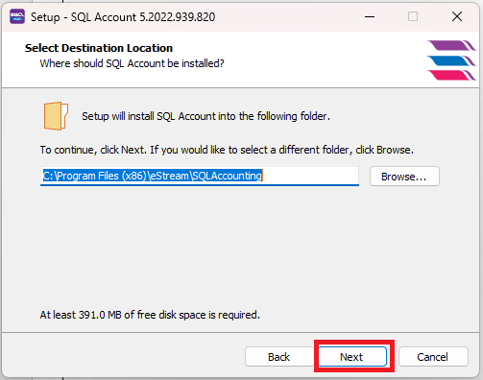

Run the SQL Installer to start the installation, Select **I accept the agreement** and click on **Next**. Set the Destination Location as it is and click **Next**.

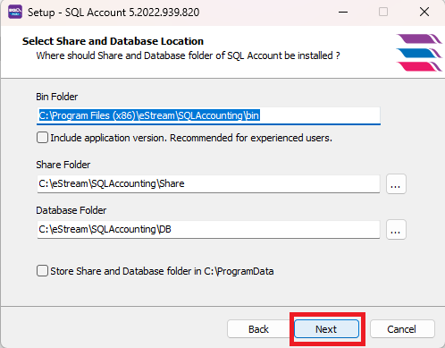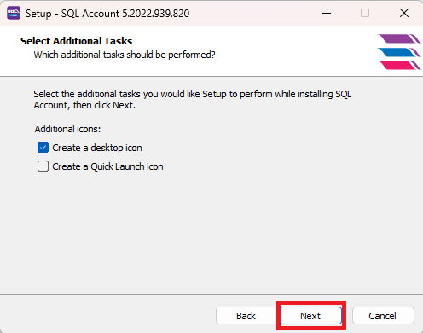

Set the **Share** **and** **Database** **Location** as it is and click **Next**. Tick on **Create** **a** **desktop** **icon** and click **Next**.

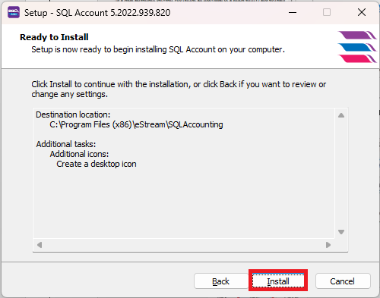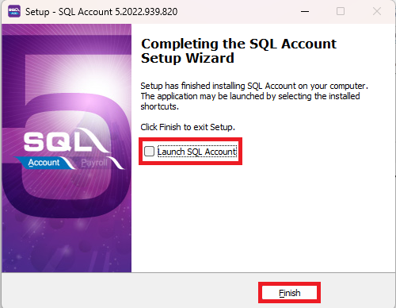

Click on **Install** to start installation and wait until it is complete. Untick the **Launch** **SQL** **Account** and click on **Finish**.

# TV Menu Setup

# Android TV

## Android TV Setup

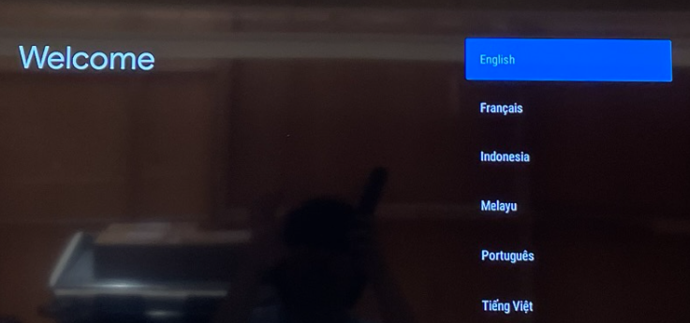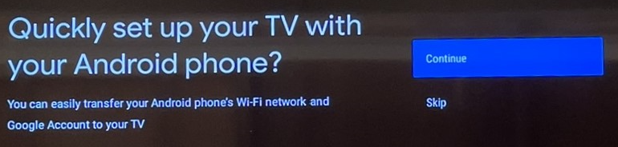

Select **English** for Language. Select **Skip** to set up your TV with Android phone.

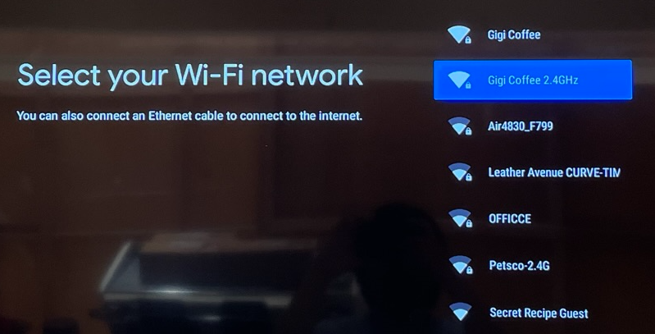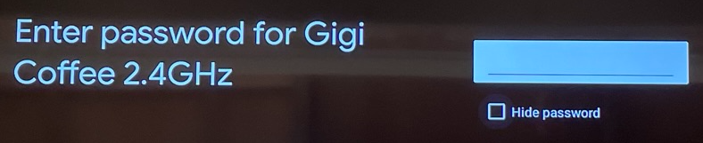

Select Wi-Fi network, choose outlet Wi-Fi. **SSID – Gigi Coffee**. Enter Wi-Fi password – **cBm1@45964**.

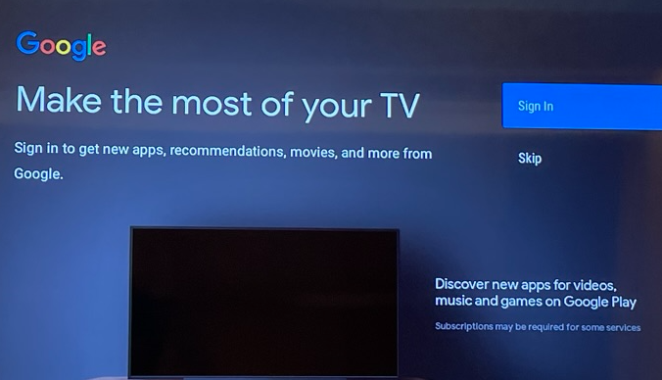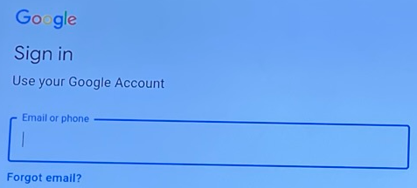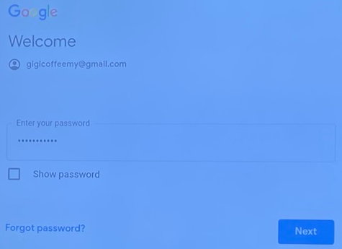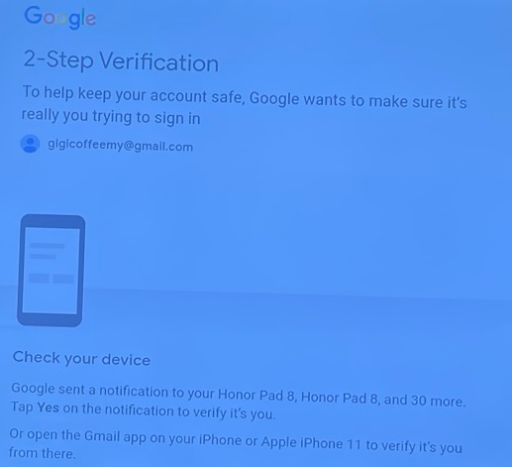

Select **Sign In** for Google account sign-in. Credentials as per below:

**Username: gigicoffeemy**

**Password: btbrands@89**

Proceed with **2-Step Verification** by verifying via your **device notification** or **sent verification code via phone number** or using **8 digits back up code**.

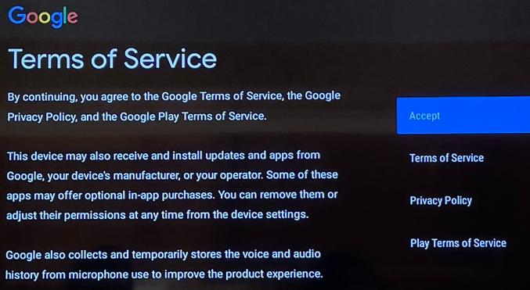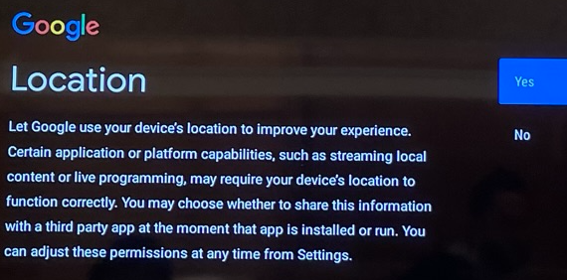

Select **Accept** for Terms of Service. Select **No** for Location.

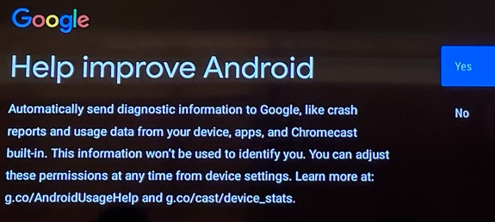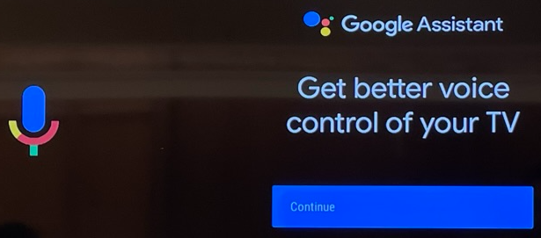

Select **No** for Help improve Android and **Continue**.

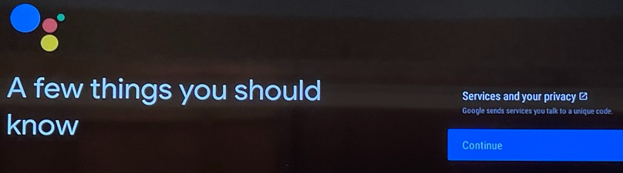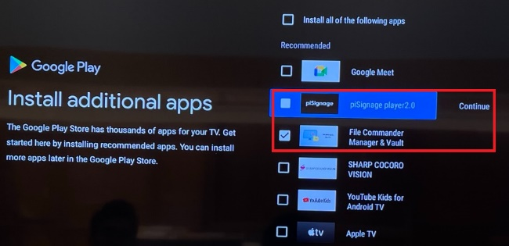

Select **Continue.** Install additional apps by selecting **piSignage player 2.0**, **File Commander Manager & Vault** and select **Continue**.

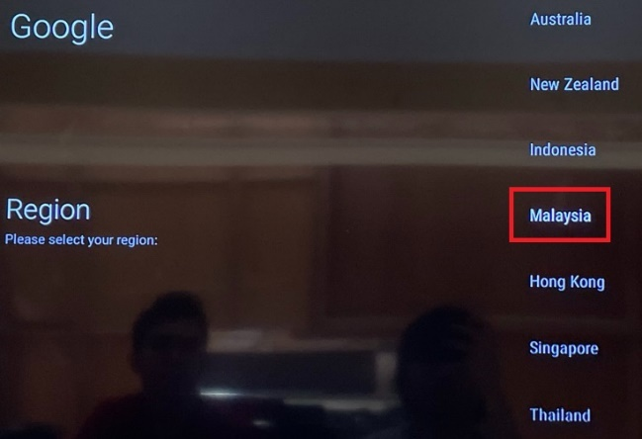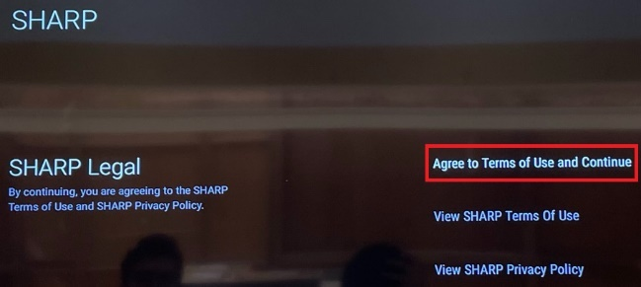

Select **Malaysia** for region and **Agree to Terms of Use and Continue**.

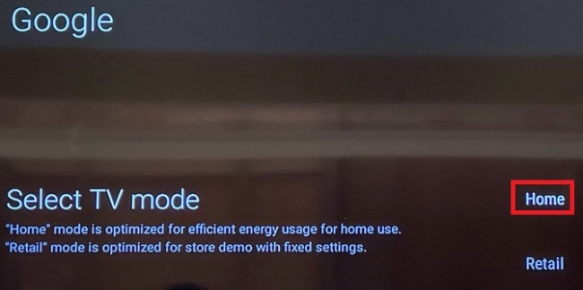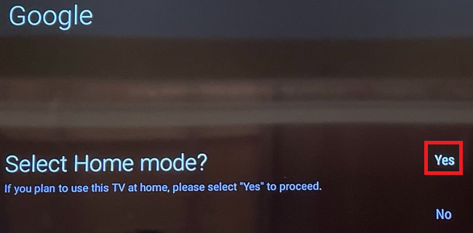

Select Home for TV Mode and select Yes.

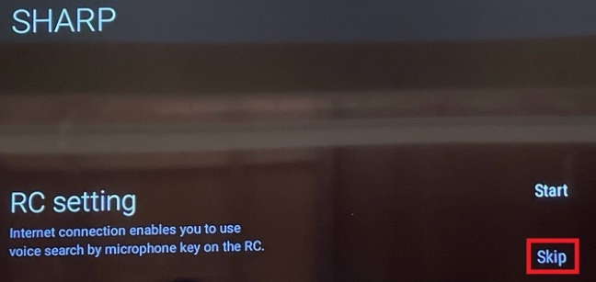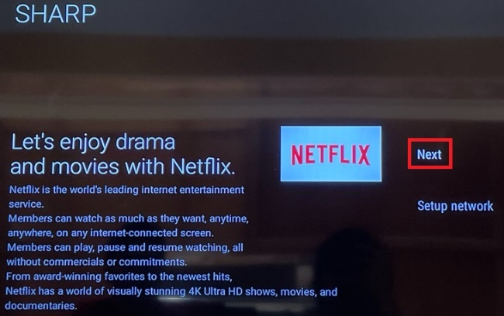

**Skip** the RC setting and select **Next** for Netflix setup.

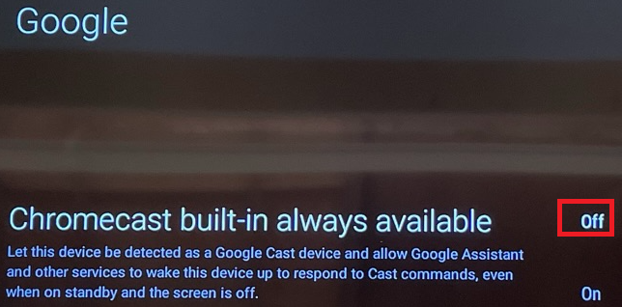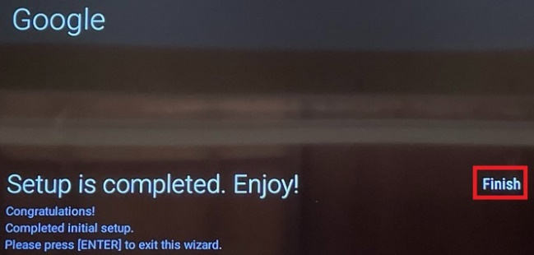

Select **Off** for Chromecast built-in always available and select **Finish** to complete.

## Android TV Configuration

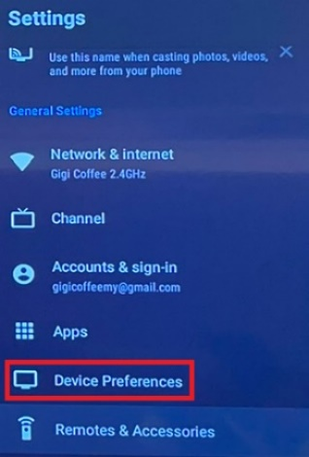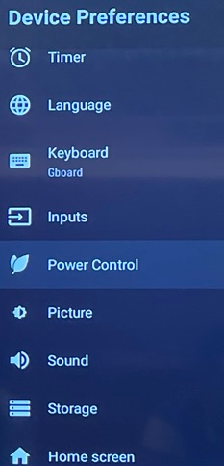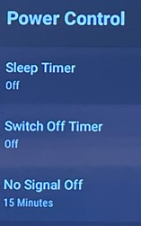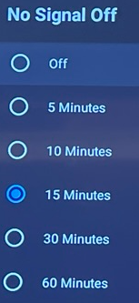

Press Home button, go to **Settings** icon and scroll down to **Device** **Preferences.** Scroll down to **Power** **Control**, scroll down to **No Signal Off** and Select **Off**.

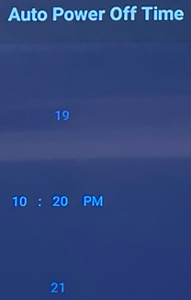

Go to **Settings** icon and scroll down to **Device** **Preferences**. Scroll down to **Timer**, scroll down to **Auto Power On/Off Time**. Set the timer for **Auto Power On/Off Time** based on Outlet Opening and Closing.

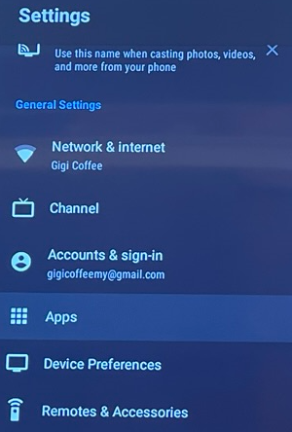 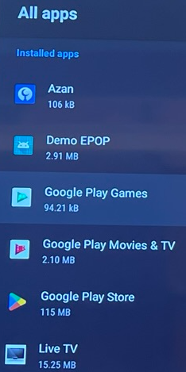

Go to Settings and scroll down to Apps, scroll down to All Apps, and disable or uninstall apps listed below:

**Google Play Games, Google Play Movies & TV, Prime Video, Red Bull TV, Spotify, TED, YouTube and YouTube Music.**

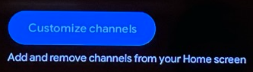 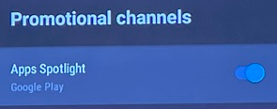

Scroll down to **Customize** **Channel**, scroll to **Promotional** **channels** and **Disable** **Apps** **Spotlight**.

## TV Menu Apps Installation

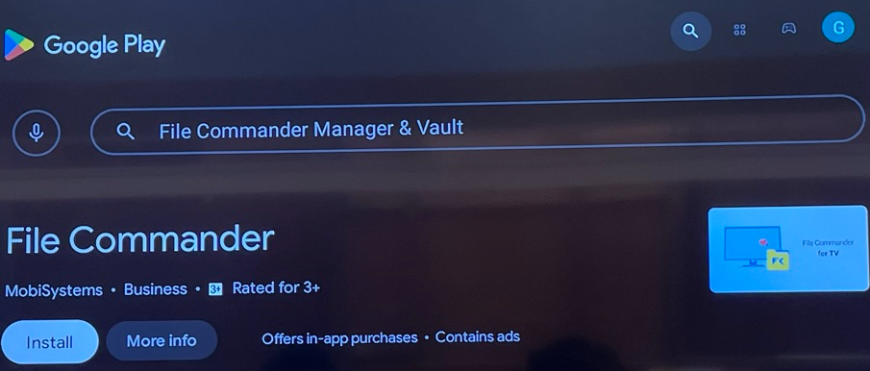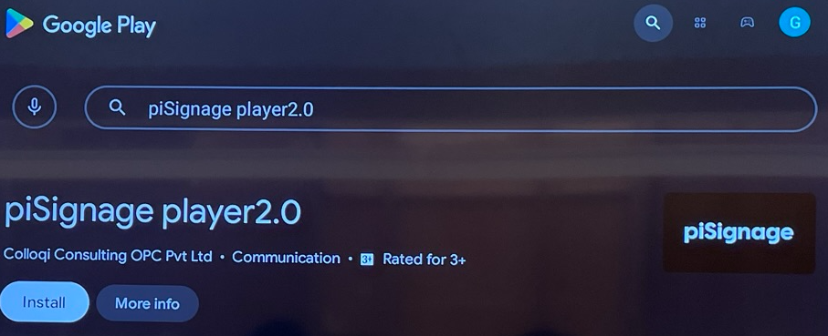

Go to **Google Play Store**, search for **File Commander** and **piSignage player 2.0** and install both Apps.

# Google TV

## Google TV Setup

## Google TV Configuration

## TV Menu Apps Installation